📘 Documentation: Analyzing Student Performance by Parental Education Level

📌 1. Importing Libraries and Dataset
import pandas as pd
import matplotlib.pyplot as plt
import seaborn as sns

students = pd.read_csv('StudentsPerformance.csv')
students.head()
- Purpose: Load essential libraries (pandas, matplotlib, seaborn) and read the dataset.
- Output: Displays the first few rows of the student performance dataset.

📌 2. Creating a DataFrame
students_df = pd.DataFrame(students)
students_df.head()
- Purpose: Ensure the dataset is loaded into a DataFrame (students_df) for further analysis.
- Output: Shows the first few entries for a quick glance.

📊 3. Visualization: Math Score by Parental Education Level
sns.catplot(
x='parental level of education',
y='math score',
hue='test preparation course',
data=students_df,
kind='violin',
palette='Set2'
)
- Chart Type: Violin plot
- Insight: Shows the distribution of math scores grouped by parental education and test prep completion.
- 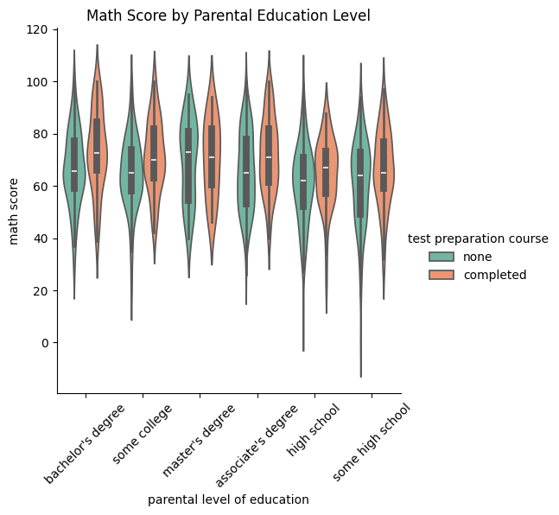

📊 4. Visualization: Reading Score by Parental Education Level
sns.catplot(
x='parental level of education',
y='reading score',
hue='test preparation course',
data=students_df,
kind='boxen',
palette='Spectral'
)
- Chart Type: Boxen plot
- Insight: Analyzes how reading scores vary with parental education and test preparation.
- 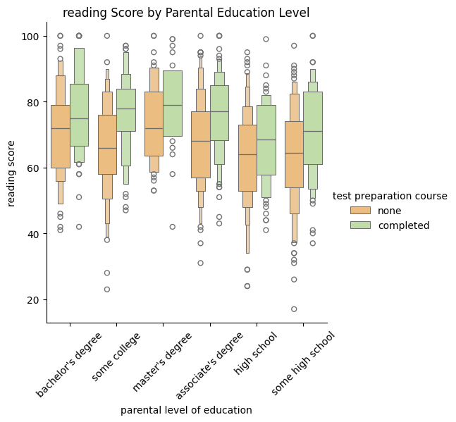

📊 5. Visualization: Writing Score by Parental Education Level
sns.catplot(
x='parental level of education',
y='writing score',
hue='test preparation course',
data=students_df,
kind='box',
palette='Set3'
)
- Chart Type: Box plot
- Insight: Highlights trends in writing scores across parental education levels.
- 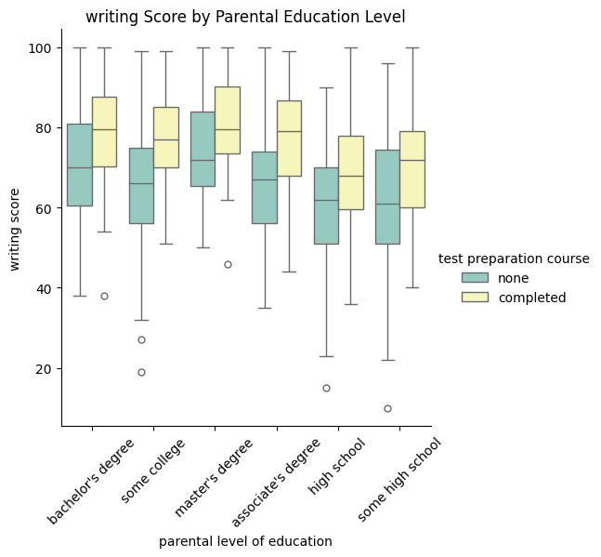

🔁 6. Scatter Plot: Math vs Reading Scores
sns.relplot(
x='math score',
y='reading score',
hue='parental level of education',
size='writing score',
data=students_df,
kind='scatter',
palette='viridis'
)
- Purpose: Shows correlation between math and reading scores, with color denoting parental education and size representing writing score.
- 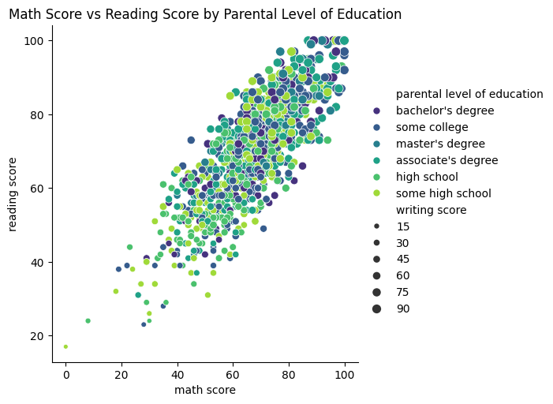

🔁 7. Scatter Plot: Math vs Writing Scores
sns.relplot(
x='math score',
y='writing score',
hue='parental level of education',
size='reading score',
data=students_df,
kind='scatter',
palette='flare'
)
- Purpose: Explores the relationship between math and writing scores.
- 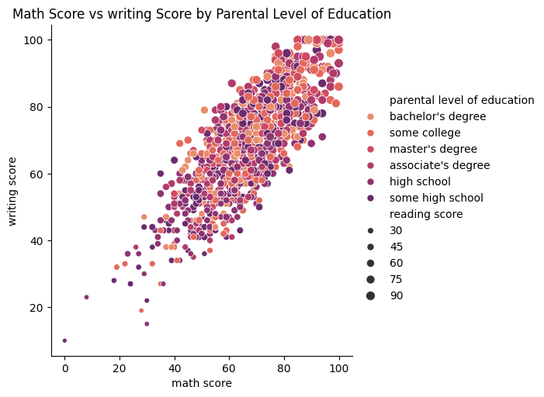

🔁 8. Scatter Plot: Writing vs Reading Scores
sns.relplot(
x='writing score',
y='reading score',
hue='parental level of education',
size='reading score',
data=students_df,
kind='scatter',
palette='Blues'
)
- Purpose: Visualizes the link between writing and reading scores.
- 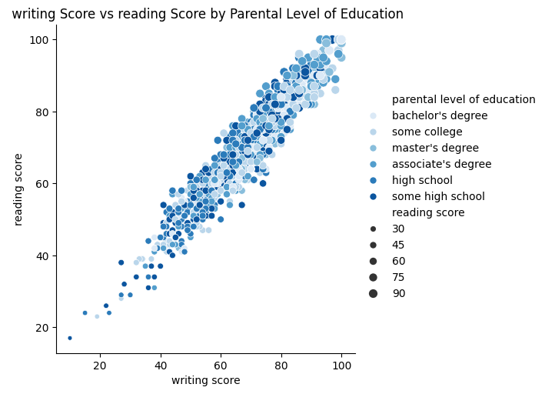

📈 9. KDE Plot: Math Score Distribution
sns.displot(
x="math score",
hue="parental level of education",
multiple="stack",
kind="kde",
data=students
)
- Chart Type: Kernel Density Estimate (KDE)
- Insight: Compares the density of math scores across different parental education levels.
- 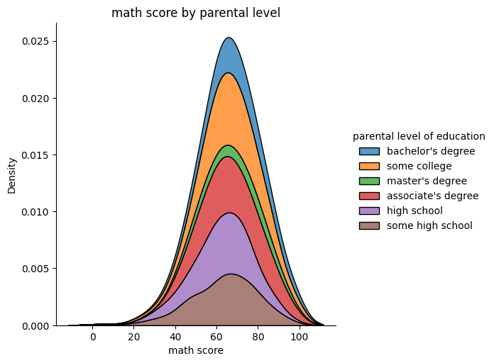

📈 10. KDE Plot: Reading Score Distribution
sns.displot(
x="reading score",
hue="parental level of education",
multiple="stack",
kind="kde",
data=students,
palette='rocket'
)
- Purpose: Shows how reading scores are distributed with respect to parental education.
- 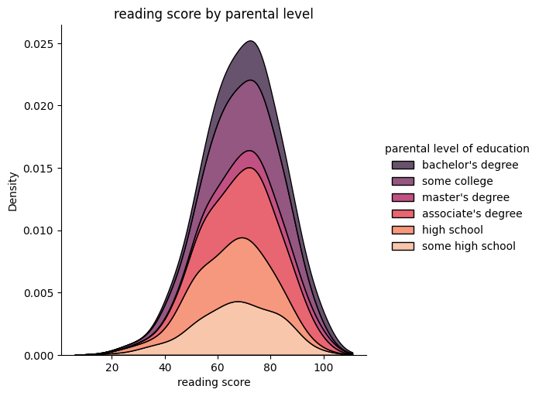

📈 11. KDE Plot: Writing Score Distribution
sns.displot(
x="writing score",
hue="parental level of education",
multiple="stack",
kind="kde",
data=students,
palette='crest'
)
- Purpose: Displays the distribution of writing scores based on parental education level.

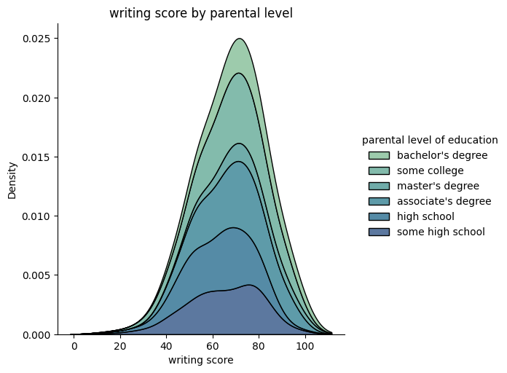

Heat map

sns.heatmap(
X=”Represents the math scores”
Y=”axis:Represents the density of the scores “
Data=students_df
Kind=”heatmap”
cmap="Greens"(cmap sets the color of the graphs in shades)
annot=True (annot=True shows the count number in each cell)
fmt="d" (fmt tells seaborn to set each cell to interger and)
)

Chart Type: Heatmap
Insight: Analysis the counts of parental education level and math score bin
The heatmap indicates a noticeable trend of students whose parents have higher levels of education tend to score better in maths.
